[support@centos msp-scm]$ ansible-playbook playbook-dco-nrpe.yml -i list_of_hosts --become --extra-vars "ansible_user=bsv ansible_password=$(pass common/linux) ansible_sudo_pass=$(pass common/linux) ansi
ble_ssh_common_args='-oStrictHostKeyChecking=no -oPubkeyAuthentication=no'" -f 20 --check

PLAY [all[0]] *********************************************************************************************************************************************************************************************

TASK [assert] *********************************************************************************************************************************************************************************************
Friday 13 September 2019 13:01:42 +0300 (0:00:00.102) 0:00:00.102 ******
ok: [m1-gp-prod-sdw01] => {
"changed": false
}

MSG:

All assertions passed

PLAY [all] ************************************************************************************************************************************************************************************************

TASK [Gathering Facts] ************************************************************************************************************************************************************************************
Friday 13 September 2019 13:01:42 +0300 (0:00:00.102) 0:00:00.205 ******
[WARNING]: Unhandled error in Python interpreter discovery for host m1-gp-prod-sdw02: Failed to connect to the host via ssh: @@@@@@@@@@@@@@@@@@@@@@@@@@@@@@@@@@@@@@@@@@@@@@@@@@@@@@@@@@@ @ WARNING:
REMOTE HOST IDENTIFICATION HAS CHANGED! @ @@@@@@@@@@@@@@@@@@@@@@@@@@@@@@@@@@@@@@@@@@@@@@@@@@@@@@@@@@@ IT IS POSSIBLE THAT SOMEONE IS DOING SOMETHING NASTY! Someone could be eavesdropping on you
right now (man-in-the-middle attack)! It is also possible that a host key has just been changed. The fingerprint for the ECDSA key sent by the remote host is
c3:a7:45:c1:c1:ca:1b:06:8a:05:3a:2f:8d:b5:f1:9c. Please contact your system administrator. Add correct host key in /home/support/.ssh/known_hosts to get rid of this message. Offending ECDSA key in
/home/support/.ssh/known_hosts:1550 Password authentication is disabled to avoid man-in-the-middle attacks. Keyboard-interactive authentication is disabled to avoid man-in-the-middle attacks.
Permission denied (publickey,password).

...

MSG:

Data could not be sent to remote host "m1-gp-prod-sdw05". Make sure this host can be reached over ssh: @@@@@@@@@@@@@@@@@@@@@@@@@@@@@@@@@@@@@@@@@@@@@@@@@@@@@@@@@@@
@ WARNING: REMOTE HOST IDENTIFICATION HAS CHANGED! @
@@@@@@@@@@@@@@@@@@@@@@@@@@@@@@@@@@@@@@@@@@@@@@@@@@@@@@@@@@@
IT IS POSSIBLE THAT SOMEONE IS DOING SOMETHING NASTY!
Someone could be eavesdropping on you right now (man-in-the-middle attack)!
It is also possible that a host key has just been changed.
The fingerprint for the ECDSA key sent by the remote host is
bf:b2:6b:75:be:8e:97:47:cd:6a:65:bd:5d:10:f1:7e.
Please contact your system administrator.
Add correct host key in /home/support/.ssh/known_hosts to get rid of this message.
Offending ECDSA key in /home/support/.ssh/known_hosts:1562
Password authentication is disabled to avoid man-in-the-middle attacks.
Keyboard-interactive authentication is disabled to avoid man-in-the-middle attacks.
Permission denied (publickey,password).

PLAY RECAP ************************************************************************************************************************************************************************************************
m1-gp-prod-sdw01 : ok=1 changed=0 unreachable=1 failed=0 skipped=0 rescued=0 ignored=0
m1-gp-prod-sdw02 : ok=0 changed=0 unreachable=1 failed=0 skipped=0 rescued=0 ignored=0
m1-gp-prod-sdw03 : ok=0 changed=0 unreachable=1 failed=0 skipped=0 rescued=0 ignored=0
m1-gp-prod-sdw04 : ok=0 changed=0 unreachable=1 failed=0 skipped=0 rescued=0 ignored=0
m1-gp-prod-sdw05 : ok=0 changed=0 unreachable=1 failed=0 skipped=0 rescued=0 ignored=0

Friday 13 September 2019 13:02:43 +0300 (0:01:00.874) 0:01:01.079 ******
===============================================================================
Gathering Facts ----------------------------------------------------------------------------------------------------------------------------------------------------------------------------------- 60.87s
assert --------------------------------------------------------------------------------------------------------------------------------------------------------------------------------------------- 0.10s
[support@centos msp-scm]$

#
# This command works much better.
#

[support@centos msp-scm]$ ansible-playbook playbook-dco-nrpe.yml -i list_of_hosts --become --extra-vars "ansible_user=bsv ansible_password=$(pass common/linux) ansible_sudo_pass=$(pass common/linux) ansible_ssh_common_args='-oStrictHostKeyChecking=no -oPubkeyAuthentication=no -oUserKnownHostsFile=/dev/null'" -f 20 --check

PLAY [all[0]] *********************************************************************************************************************************************************************************************

TASK [assert] *********************************************************************************************************************************************************************************************
Friday 13 September 2019 13:06:26 +0300 (0:00:00.089) 0:00:00.089 ******
ok: [m1-gp-prod-sdw01] => {
"changed": false
}

MSG:

All assertions passed

PLAY [all] ************************************************************************************************************************************************************************************************

TASK [Gathering Facts] ************************************************************************************************************************************************************************************
Friday 13 September 2019 13:06:26 +0300 (0:00:00.106) 0:00:00.196 ******
ok: [m1-gp-prod-sdw01]
ok: [m1-gp-prod-sdw05]
ok: [m1-gp-prod-sdw02]
ok: [m1-gp-prod-sdw03]
ok: [m1-gp-prod-sdw04]
...
MSG:

The task includes an option with an undefined variable. The error was: 'common_versions' is undefined

The error appears to be in '/home/support/work/20190605-1120.msp-scm/msp-scm/roles/dco.service.nrpe/tasks/install.yml': line 3, column 3, but may
be elsewhere in the file depending on the exact syntax problem.

The offending line appears to be:

- name: Install | Installing nrpe
^ here

PLAY RECAP ************************************************************************************************************************************************************************************************
m1-gp-prod-sdw01 : ok=13 changed=0 unreachable=0 failed=1 skipped=9 rescued=0 ignored=0
m1-gp-prod-sdw02 : ok=12 changed=0 unreachable=0 failed=1 skipped=9 rescued=0 ignored=0
m1-gp-prod-sdw03 : ok=12 changed=0 unreachable=0 failed=1 skipped=9 rescued=0 ignored=0
m1-gp-prod-sdw04 : ok=12 changed=0 unreachable=0 failed=1 skipped=9 rescued=0 ignored=0
m1-gp-prod-sdw05 : ok=12 changed=0 unreachable=0 failed=1 skipped=9 rescued=0 ignored=0

Friday 13 September 2019 13:06:53 +0300 (0:00:00.513) 0:00:27.166 ******
===============================================================================
Gathering Facts ------------------------------------------------------------------------------------------------------------------------------------------------------------------------------------ 5.79s
dco.common.useful_packages : Main | Installing useful packages ------------------------------------------------------------------------------------------------------------------------------------- 2.46s
msp.common.repo : Add rhel msp repo | Creating MSP repo for dell-os_independent -------------------------------------------------------------------------------------------------------------------- 1.95s
msp.common.repo : Add rhel msp repo | Check if repo http://repo-linux.tcsbank.ru/dell/dsu/os_independent/ exists ----------------------------------------------------------------------------------- 1.72s
msp.common.repo : Add rhel msp repo | Creating MSP repo for dell-os_dependent ---------------------------------------------------------------------------------------------------------------------- 1.55s
msp.common.repo : RedHat | Add msp repos ----------------------------------------------------------------------------------------------------------------------------------------------------------- 1.38s
msp.common.repo : RedHat | Absent Cobbler repo file ------------------------------------------------------------------------------------------------------------------------------------------------ 1.33s
msp.common.repo : Add rhel msp repo | Check if repo http://repo-linux.tcsbank.ru/dell/dsu/os_dependent/7/ exists ----------------------------------------------------------------------------------- 1.31s
msp.common.repo : RedHat | Clean metadata (for version downgrade) ---------------------------------------------------------------------------------------------------------------------------------- 1.27s
msp.common.repo : include -------------------------------------------------------------------------------------------------------------------------------------------------------------------------- 1.04s
msp.common.repo : Fail ----------------------------------------------------------------------------------------------------------------------------------------------------------------------------- 0.80s
msp.common.repo : Fail ----------------------------------------------------------------------------------------------------------------------------------------------------------------------------- 0.70s
msp.common.repo : Add rhel msp repo | Join url for dell-os_independent repo ------------------------------------------------------------------------------------------------------------------------ 0.69s
msp.common.repo : Add rhel msp repo | Join url for dell-os_dependent repo -------------------------------------------------------------------------------------------------------------------------- 0.67s
dco.common.useful_packages : Main | Include OS-Specific variables ---------------------------------------------------------------------------------------------------------------------------------- 0.66s
dco.service.nrpe : Main | Include OS-Specific variables -------------------------------------------------------------------------------------------------------------------------------------------- 0.64s
msp.common.repo : RedHat | Install and configure base repos ---------------------------------------------------------------------------------------------------------------------------------------- 0.64s
msp.common.repo : include -------------------------------------------------------------------------------------------------------------------------------------------------------------------------- 0.63s
msp.common.repo : include -------------------------------------------------------------------------------------------------------------------------------------------------------------------------- 0.61s
msp.common.repo : include -------------------------------------------------------------------------------------------------------------------------------------------------------------------------- 0.61s
[support@centos msp-scm]$

[support@centos msp-scm]$ ansible-playbook playbook-dco-nrpe.yml -i list_of_hosts --become --extra-vars "ansible_user=bsv ansible_password=$(pass common/linux) ansible_sudo_pass=$(pass common/linux) ansi
ble_ssh_common_args='-oStrictHostKeyChecking=no -oPubkeyAuthentication=no -oUserKnownHostsFile=/dev/null'" -f 20 --check --extra-vars=@builds/dco/staging-builds.yml

PLAY [all[0]] *********************************************************************************************************************************************************************************************

TASK [assert] *********************************************************************************************************************************************************************************************
Friday 13 September 2019 13:18:04 +0300 (0:00:00.090) 0:00:00.095 ******
ok: [m1-gp-prod-sdw01] => {
"changed": false
}

MSG:

All assertions passed

PLAY [all] ************************************************************************************************************************************************************************************************

TASK [Gathering Facts] ************************************************************************************************************************************************************************************
Friday 13 September 2019 13:18:04 +0300 (0:00:00.090) 0:00:00.185 ******
ok: [m1-gp-prod-sdw03]
ok: [m1-gp-prod-sdw01]
ok: [m1-gp-prod-sdw02]
ok: [m1-gp-prod-sdw05]
ok: [m1-gp-prod-sdw04]
...
TASK [dco.service.nrpe : Configure | Plugins] *************************************************************************************************************************************************************
Friday 13 September 2019 13:18:35 +0300 (0:00:01.656) 0:00:30.482 ******
ok: [m1-gp-prod-sdw03] => (item=/home/support/work/20190605-1120.msp-scm/msp-scm/roles/dco.service.nrpe/files/plugins/autofailover.sh)
ok: [m1-gp-prod-sdw01] => (item=/home/support/work/20190605-1120.msp-scm/msp-scm/roles/dco.service.nrpe/files/plugins/autofailover.sh)
...
ok: [m1-gp-prod-sdw02] => (item=/home/support/work/20190605-1120.msp-scm/msp-scm/roles/dco.service.nrpe/files/plugins/pwd-expire.sh)
ok: [m1-gp-prod-sdw04] => (item=/home/support/work/20190605-1120.msp-scm/msp-scm/roles/dco.service.nrpe/files/plugins/pwd-expire.sh)
ok: [m1-gp-prod-sdw01] => (item=/home/support/work/20190605-1120.msp-scm/msp-scm/roles/dco.service.nrpe/files/plugins/check_md.sh)
changed: [m1-gp-prod-sdw05] => (item=/home/support/work/20190605-1120.msp-scm/msp-scm/roles/dco.service.nrpe/files/plugins/check_nvme.sh)
changed: [m1-gp-prod-sdw01] => (item=/home/support/work/20190605-1120.msp-scm/msp-scm/roles/dco.service.nrpe/files/plugins/check_nvme.sh)
ok: [m1-gp-prod-sdw03] => (item=/home/support/work/20190605-1120.msp-scm/msp-scm/roles/dco.service.nrpe/files/plugins/check_md.sh)
ok: [m1-gp-prod-sdw04] => (item=/home/support/work/20190605-1120.msp-scm/msp-scm/roles/dco.service.nrpe/files/plugins/check_md.sh)
ok: [m1-gp-prod-sdw02] => (item=/home/support/work/20190605-1120.msp-scm/msp-scm/roles/dco.service.nrpe/files/plugins/check_md.sh)
changed: [m1-gp-prod-sdw04] => (item=/home/support/work/20190605-1120.msp-scm/msp-scm/roles/dco.service.nrpe/files/plugins/check_nvme.sh)
changed: [m1-gp-prod-sdw02] => (item=/home/support/work/20190605-1120.msp-scm/msp-scm/roles/dco.service.nrpe/files/plugins/check_nvme.sh)
changed: [m1-gp-prod-sdw03] => (item=/home/support/work/20190605-1120.msp-scm/msp-scm/roles/dco.service.nrpe/files/plugins/check_nvme.sh)

...
PLAY RECAP ************************************************************************************************************************************************************************************************
m1-gp-prod-sdw01 : ok=23 changed=3 unreachable=0 failed=0 skipped=9 rescued=0 ignored=0
m1-gp-prod-sdw02 : ok=22 changed=3 unreachable=0 failed=0 skipped=9 rescued=0 ignored=0
m1-gp-prod-sdw03 : ok=22 changed=3 unreachable=0 failed=0 skipped=9 rescued=0 ignored=0
m1-gp-prod-sdw04 : ok=22 changed=3 unreachable=0 failed=0 skipped=9 rescued=0 ignored=0
m1-gp-prod-sdw05 : ok=22 changed=3 unreachable=0 failed=0 skipped=9 rescued=0 ignored=0

Friday 13 September 2019 13:19:02 +0300 (0:00:01.113) 0:00:58.057 ******
===============================================================================
dco.service.nrpe : Configure | Plugins ------------------------------------------------------------------------------------------------------------------------------------------------------------ 18.23s
Gathering Facts ------------------------------------------------------------------------------------------------------------------------------------------------------------------------------------ 4.70s
dco.service.nrpe : Install | Installing nrpe required packages ------------------------------------------------------------------------------------------------------------------------------------- 2.28s
dco.service.nrpe : Configure | Ensure NRPE server is running --------------------------------------------------------------------------------------------------------------------------------------- 2.01s
dco.service.nrpe : Install | Installing nrpe ------------------------------------------------------------------------------------------------------------------------------------------------------- 1.94s
msp.common.repo : Add rhel msp repo | Creating MSP repo for dell-os_independent -------------------------------------------------------------------------------------------------------------------- 1.91s
dco.service.nrpe : Configure | Render command config ----------------------------------------------------------------------------------------------------------------------------------------------- 1.90s
dco.service.nrpe : Configure | Render check_ntp_time check ----------------------------------------------------------------------------------------------------------------------------------------- 1.71s
dco.common.useful_packages : Main | Installing useful packages ------------------------------------------------------------------------------------------------------------------------------------- 1.67s
dco.service.nrpe : Configure | Main config --------------------------------------------------------------------------------------------------------------------------------------------------------- 1.66s
msp.common.repo : Add rhel msp repo | Check if repo http://repo-linux.tcsbank.ru/dell/dsu/os_independent/ exists ----------------------------------------------------------------------------------- 1.64s
msp.common.repo : Add rhel msp repo | Creating MSP repo for dell-os_dependent ---------------------------------------------------------------------------------------------------------------------- 1.56s
dco.service.nrpe : SNMP | copy snmpd.conf ---------------------------------------------------------------------------------------------------------------------------------------------------------- 1.44s
msp.common.repo : RedHat | Absent Cobbler repo file ------------------------------------------------------------------------------------------------------------------------------------------------ 1.34s
msp.common.repo : RedHat | Add msp repos ----------------------------------------------------------------------------------------------------------------------------------------------------------- 1.33s
msp.common.repo : Add rhel msp repo | Check if repo http://repo-linux.tcsbank.ru/dell/dsu/os_dependent/7/ exists ----------------------------------------------------------------------------------- 1.29s
msp.common.repo : RedHat | Clean metadata (for version downgrade) ---------------------------------------------------------------------------------------------------------------------------------- 1.28s
dco.service.nrpe : SNMP | Ensure SNMPD deamon is running and enabled ------------------------------------------------------------------------------------------------------------------------------- 1.18s
dco.service.nrpe : restart nrpe -------------------------------------------------------------------------------------------------------------------------------------------------------------------- 1.11s
msp.common.repo : include -------------------------------------------------------------------------------------------------------------------------------------------------------------------------- 1.04s
[support@centos msp-scm]$

#
# Unsuccessful attemption to apply only one task.
# Here I’ve added tags option.

[support@centos msp-scm]$ cat roles/dco.service.nrpe/tasks/configure.yml
---

- name: Configure | Main config
template:
src: nrpe.cfg.j2
dest: "{{ service.path }}/nrpe.cfg"
mode: 0644
owner: root
group: root
notify: restart {{ service.name }}

- name: Configure | Plugins
copy:
src: "{{ item }}"
dest: "{{ service.plugins }}"
mode: 0755
owner: root
group: root
with_fileglob: plugins/*

- name: Configure | Render check_ntp_time check
template:
src: check_ntp_time.sh.j2
dest: "{{ service.plugins }}/check_ntp_time.sh"
mode: 0755
owner: root
group: root
notify: restart {{ service.name }}

- name: Configure | Render command config
template:
src: nrpe_commands.cfg.j2
dest: "{{ service.cfg_path }}nrpe_commands.cfg"
mode: 0644
owner: root
group: root
notify: restart {{ service.name }}
tags:
- render-command-config

- name: Configure | Ensure NRPE server is running
service:
name: "{{ service.name }}"
state: started
enabled: yes
[support@centos msp-scm]$

[support@centos msp-scm]$ ansible-playbook playbook-dco-nrpe.yml -i list_of_hosts --become --extra-vars "ansible_user=bsv ansible_password=$(pass common/linux) ansible_sudo_pass=$(pass common/linux) ansi
ble_ssh_common_args='-oStrictHostKeyChecking=no -oPubkeyAuthentication=no -oUserKnownHostsFile=/dev/null'" -f 20 --check --extra-vars=@builds/dco/staging-builds.yml --tags "render-command-config"

PLAY [all[0]] *********************************************************************************************************************************************************************************************

PLAY [all] ************************************************************************************************************************************************************************************************

TASK [Gathering Facts] ************************************************************************************************************************************************************************************
Friday 13 September 2019 13:39:49 +0300 (0:00:00.148) 0:00:00.148 ******
ok: [m1-gp-prod-sdw05]
ok: [m1-gp-prod-sdw01]
ok: [m1-gp-prod-sdw04]
ok: [m1-gp-prod-sdw03]
ok: [m1-gp-prod-sdw02]
...
TASK [dco.service.nrpe : Configure | Render command config] ***********************************************************************************************************************************************
Friday 13 September 2019 13:39:59 +0300 (0:00:00.615) 0:00:10.109 ******
fatal: [m1-gp-prod-sdw01]: FAILED! => {}

MSG:

The task includes an option with an undefined variable. The error was: 'dict object' has no attribute 'cfg_path'

The error appears to be in '/home/support/work/20190605-1120.msp-scm/msp-scm/roles/dco.service.nrpe/tasks/configure.yml': line 30, column 3, but may
be elsewhere in the file depending on the exact syntax problem.

The offending line appears to be:

- name: Configure | Render command config
^ here

...

PLAY RECAP ************************************************************************************************************************************************************************************************
m1-gp-prod-sdw01 : ok=4 changed=0 unreachable=0 failed=1 skipped=4 rescued=0 ignored=0
m1-gp-prod-sdw02 : ok=4 changed=0 unreachable=0 failed=1 skipped=4 rescued=0 ignored=0
m1-gp-prod-sdw03 : ok=4 changed=0 unreachable=0 failed=1 skipped=4 rescued=0 ignored=0
m1-gp-prod-sdw04 : ok=4 changed=0 unreachable=0 failed=1 skipped=4 rescued=0 ignored=0
m1-gp-prod-sdw05 : ok=4 changed=0 unreachable=0 failed=1 skipped=4 rescued=0 ignored=0

Friday 13 September 2019 13:40:00 +0300 (0:00:00.486) 0:00:10.596 ******
===============================================================================
Gathering Facts ------------------------------------------------------------------------------------------------------------------------------------------------------------------------------------ 5.15s
msp.common.repo : RedHat | Add msp repos ----------------------------------------------------------------------------------------------------------------------------------------------------------- 1.35s
msp.common.repo : include -------------------------------------------------------------------------------------------------------------------------------------------------------------------------- 1.04s
msp.common.repo : include -------------------------------------------------------------------------------------------------------------------------------------------------------------------------- 0.62s
msp.common.repo : RedHat | Install and configure base repos ---------------------------------------------------------------------------------------------------------------------------------------- 0.61s
msp.common.repo : include -------------------------------------------------------------------------------------------------------------------------------------------------------------------------- 0.61s
msp.common.repo : include -------------------------------------------------------------------------------------------------------------------------------------------------------------------------- 0.59s
dco.service.nrpe : Configure | Render command config ----------------------------------------------------------------------------------------------------------------------------------------------- 0.49s
[support@centos msp-scm]$

#
# Now apply changes.
#

[support@centos msp-scm]$ ansible-playbook playbook-dco-nrpe.yml -i list_of_hosts --become --extra-vars "ansible_user=bsv ansible_password=$(pass common/linux) ansible_sudo_pass=$(pass common/linux) ansible_ssh_common_args='-oStrictHostKeyChecking=no -oPubkeyAuthentication=no -oUserKnownHostsFile=/dev/null'" -f 20 --extra-vars=@builds/dco/staging-builds.yml

...
PLAY RECAP ************************************************************************************************************************************************************************************************
m1-gp-prod-sdw01 : ok=26 changed=3 unreachable=0 failed=0 skipped=6 rescued=0 ignored=0
m1-gp-prod-sdw02 : ok=25 changed=3 unreachable=0 failed=0 skipped=6 rescued=0 ignored=0
...
m1-gp-prod-sdw33 : ok=25 changed=4 unreachable=0 failed=0 skipped=6 rescued=0 ignored=0
...
m1-gp-prod-sdw71 : ok=25 changed=3 unreachable=0 failed=0 skipped=6 rescued=0 ignored=0
m1-gp-prod-sdw72 : ok=25 changed=3 unreachable=0 failed=0 skipped=6 rescued=0 ignored=0

Friday 13 September 2019 14:32:00 +0300 (0:00:13.788) 0:10:28.378 ******
===============================================================================
dco.service.nrpe : Configure | Plugins ----------------------------------------------------------------------------------------------------------------------------------------------------------- 167.90s
Gathering Facts ----------------------------------------------------------------------------------------------------------------------------------------------------------------------------------- 27.09s
dco.service.nrpe : Configure | Render command config ---------------------------------------------------------------------------------------------------------------------------------------------- 26.79s
dco.service.nrpe : Install | Installing nrpe required packages ------------------------------------------------------------------------------------------------------------------------------------ 25.72s
msp.common.repo : RedHat | Add msp repos ---------------------------------------------------------------------------------------------------------------------------------------------------------- 21.73s
msp.common.repo : Add rhel msp repo | Creating MSP repo for dell-os_independent ------------------------------------------------------------------------------------------------------------------- 21.24s
msp.common.repo : Add rhel msp repo | Check if repo http://repo-linux.tcsbank.ru/dell/dsu/os_independent/ exists ---------------------------------------------------------------------------------- 20.36s
dco.service.nrpe : Configure | Main config -------------------------------------------------------------------------------------------------------------------------------------------------------- 19.81s
msp.common.repo : Add rhel msp repo | Creating MSP repo for dell-os_dependent --------------------------------------------------------------------------------------------------------------------- 19.37s
dco.service.nrpe : Configure | Render check_ntp_time check ---------------------------------------------------------------------------------------------------------------------------------------- 19.32s
dco.service.nrpe : SNMP | copy snmpd.conf --------------------------------------------------------------------------------------------------------------------------------------------------------- 18.35s
msp.common.repo : Add rhel msp repo | Check if repo http://repo-linux.tcsbank.ru/dell/dsu/os_dependent/7/ exists ---------------------------------------------------------------------------------- 17.97s
dco.service.nrpe : SNMP | Ensure SNMPD deamon is running and enabled ------------------------------------------------------------------------------------------------------------------------------ 16.65s
dco.service.nrpe : Configure | Ensure NRPE server is running -------------------------------------------------------------------------------------------------------------------------------------- 16.24s
msp.common.repo : include ------------------------------------------------------------------------------------------------------------------------------------------------------------------------- 15.17s
dco.service.nrpe : Install | Installing nrpe ------------------------------------------------------------------------------------------------------------------------------------------------------ 15.12s
msp.common.repo : RedHat | Clean metadata (for version downgrade) --------------------------------------------------------------------------------------------------------------------------------- 14.74s
dco.common.useful_packages : Main | Installing useful packages ------------------------------------------------------------------------------------------------------------------------------------ 14.37s
dco.service.nrpe : restart nrpe ------------------------------------------------------------------------------------------------------------------------------------------------------------------- 13.79s
msp.common.repo : RedHat | Absent Cobbler repo file ----------------------------------------------------------------------------------------------------------------------------------------------- 12.75s
[support@centos msp-scm]$

[14:34:48 root@m1-gp-prod-sdw01 ~]# grep -e "temp_critical=70" /usr/lib64/nagios/plugins/check_nvme.sh
temp_critical=70
[14:34:51 root@m1-gp-prod-sdw01 ~]#

#
# Wrong way.
#
[support@centos msp-scm]$ git commit --author='Sergey Belogrud <s.belogrud@tinkoff.ru>' -m "Changing temperature threshhold to 70 degree for nagios nrpe checks for NVME cards on GreenPlum." roles/dco.service.nrpe/files/plugins/check_nvme.sh
[master 0e7fa32] Changing temperature threshhold to 70 degree for nagios nrpe checks for NVME cards on GreenPlum.
Author: Sergey Belogrud <s.belogrud@tinkoff.ru>
Committer: support <support@centos.7.3.work02.localdomain>
Your name and email address were configured automatically based
on your username and hostname. Please check that they are accurate.
You can suppress this message by setting them explicitly:

git config --global user.name "Your Name"
git config --global user.email you@example.com

After doing this, you may fix the identity used for this commit with:

git commit --amend --reset-author

1 file changed, 4 insertions(+), 2 deletions(-)
[support@centos msp-scm]$

[support@centos msp-scm]$ git reset HEAD~
Unstaged changes after reset:
M ansible.cfg
M playbook-dco-puppet.yml
M roles/dco.service.nrpe/files/plugins/check_nvme.sh
[support@centos msp-scm]$ git status
# On branch master
# Changes not staged for commit:
# (use "git add <file>..." to update what will be committed)
# (use "git checkout -- <file>..." to discard changes in working directory)
#
# modified: ansible.cfg
# modified: playbook-dco-puppet.yml
# modified: roles/dco.service.nrpe/files/plugins/check_nvme.sh
#
# Untracked files:
# (use "git add <file>..." to include in what will be committed)
#
# inventories/production/m1-gp-prod
# list_of_hosts
no changes added to commit (use "git add" and/or "git commit -a")
[support@centos msp-scm]$

#
# Article, where explained, how to use this playbook.
#
https://wiki.tcsbank.ru/pages/viewpage.action?spaceKey=TECHSUPPORT&title=MSP-SCM+-+Management+Service+Provider+-+Supply+Chain+Management&refresh=1568387075283&focusedCommentId=523316716&refresh=1568387115106#comment-523316716

git status

git checkout -b hotfix/check_nvme_script

git diff roles/dco.service.nrpe/files/plugins/check_nvme.sh

git add roles/dco.service.nrpe/files/plugins/check_nvme.sh

# No need to write “ansible” in the field “Component/s”.
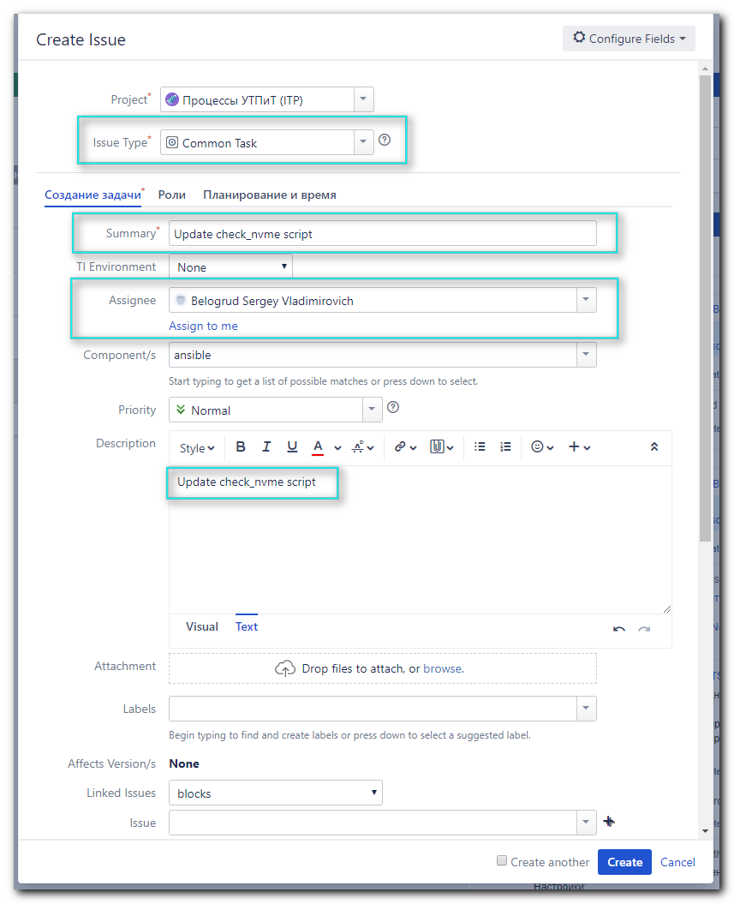

git commit --author='Sergey Belogrud <s.belogrud@tinkoff.ru>' -m "Changing temperature threshhold to 70 degree for nagios nrpe checks for NVME cards on GreenPlum, closes ITP-2423" roles/dco.service.nrpe/files/plugins/check_nvme.sh

git branch

git push origin hotfix/check_nvme_script

# After this we will receive url to Jira.

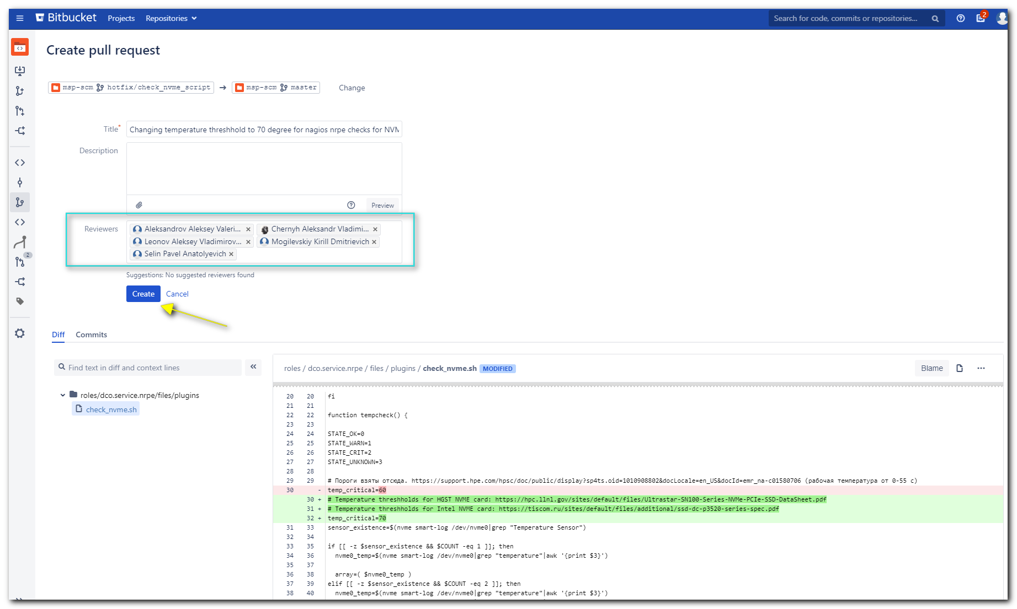
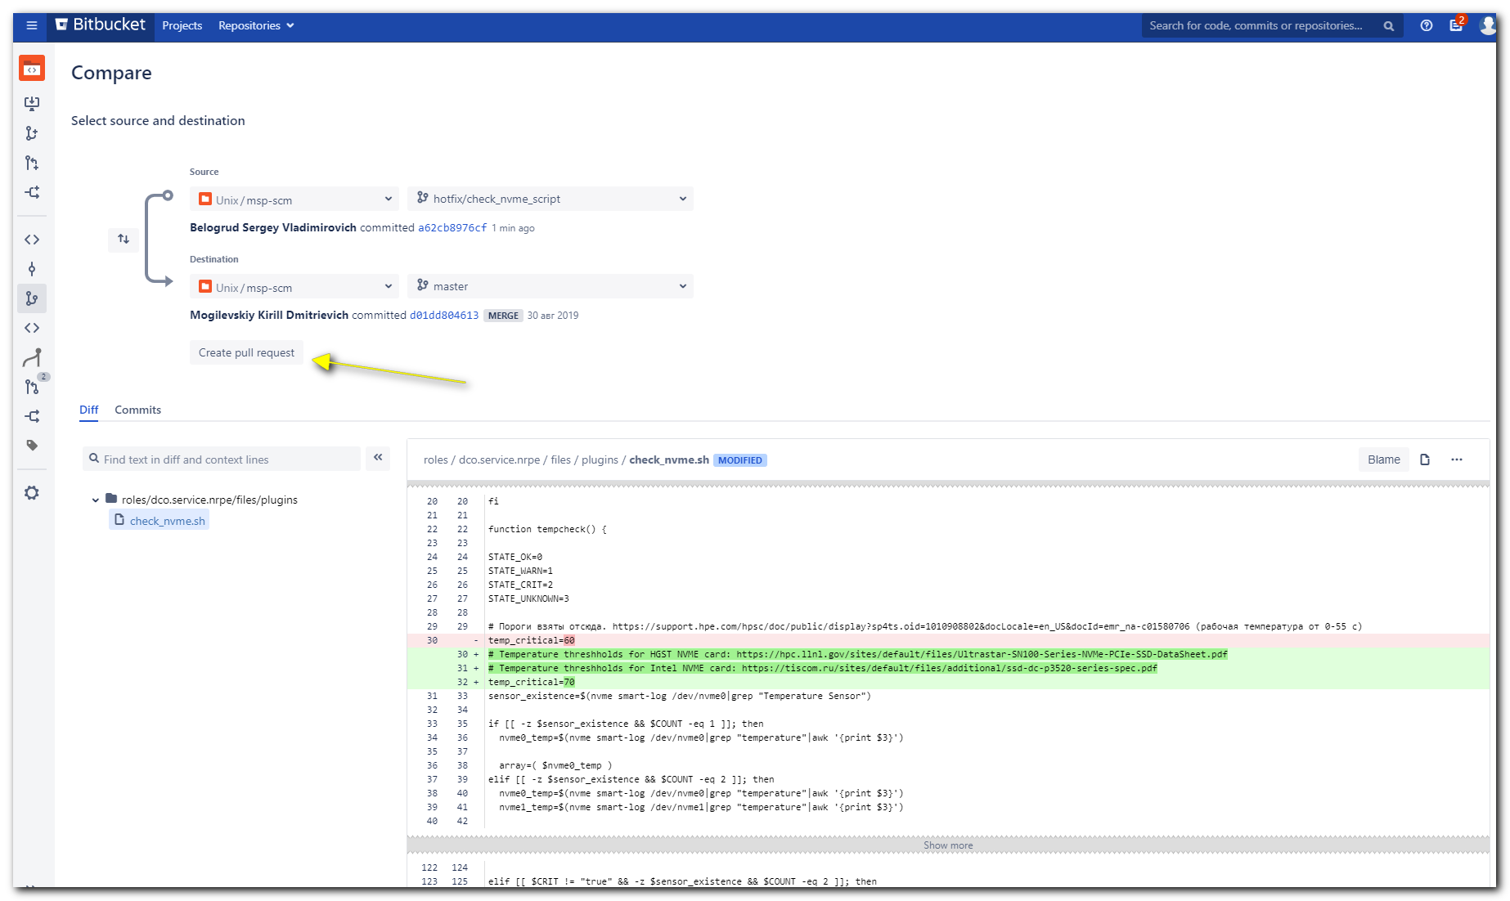

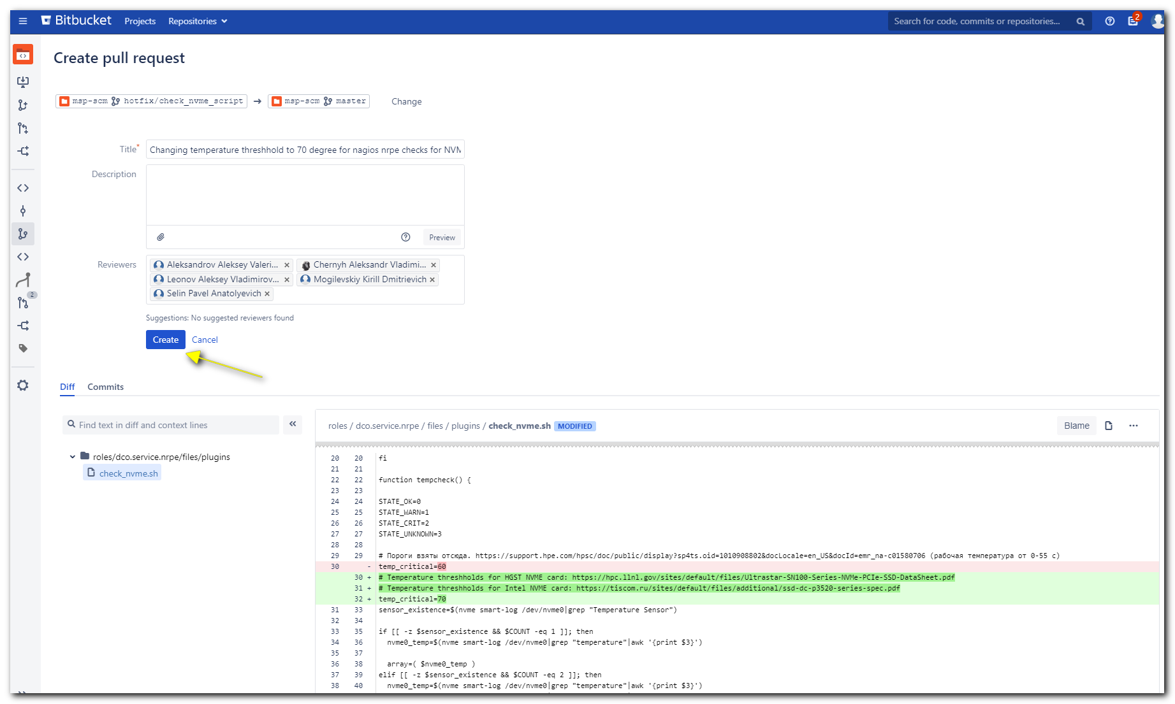

#
# Here just to see some information. And at this time it’s for nothing else.
#
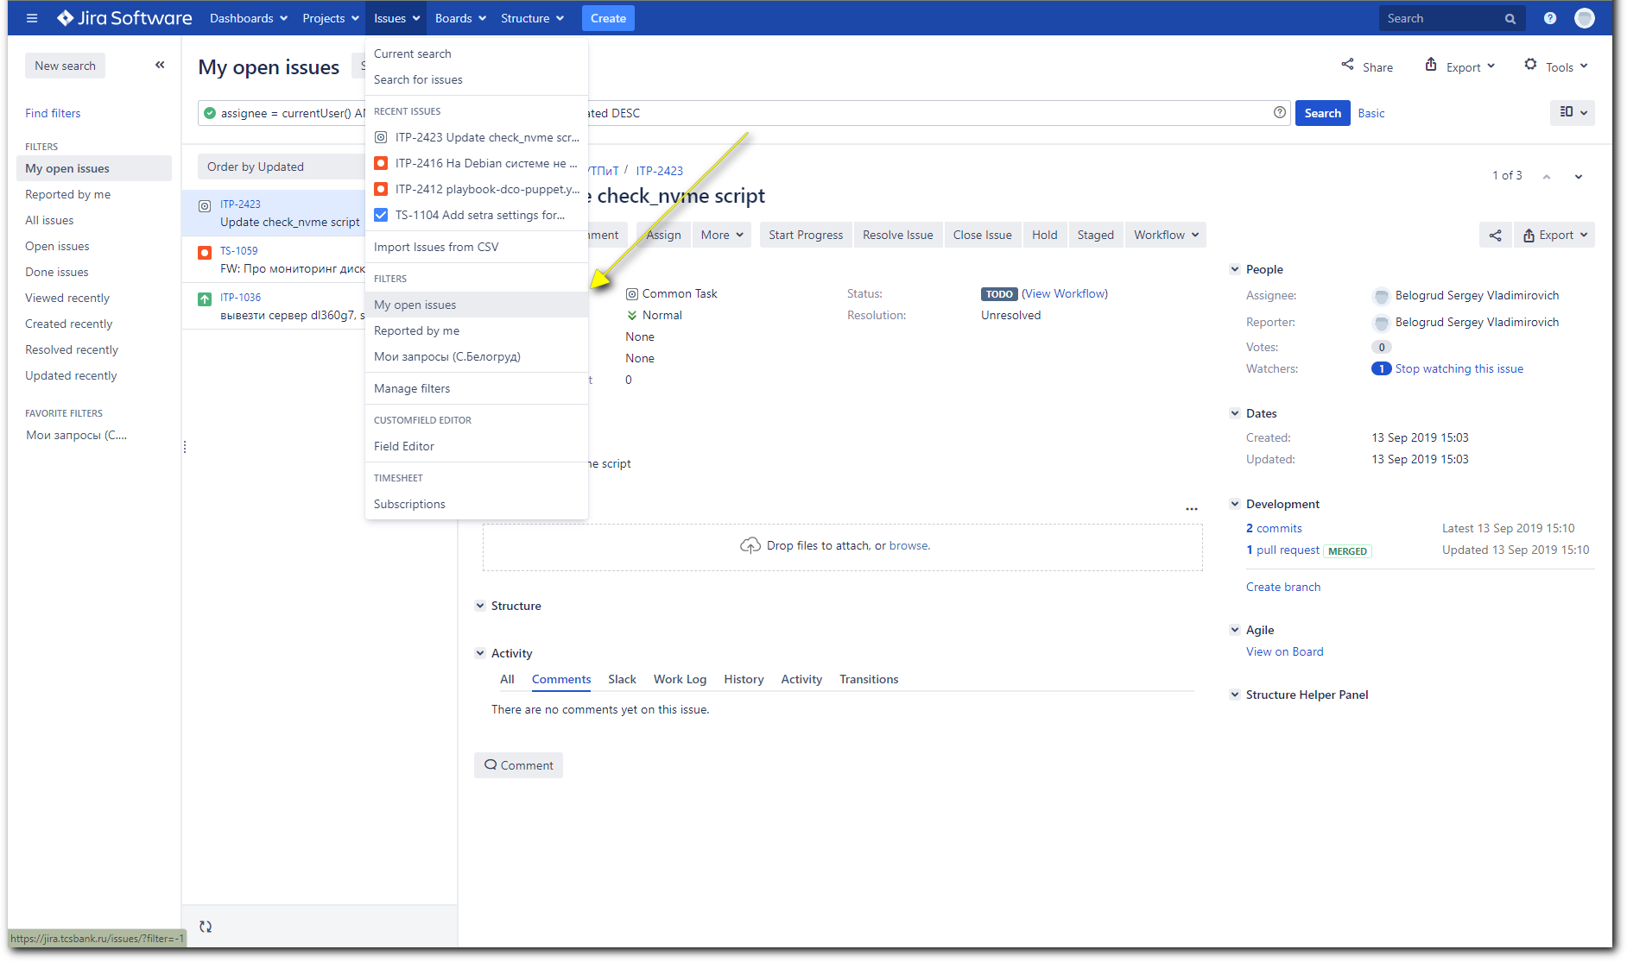

ansible-playbook playbook-dco-nrpe.yml -i inventory/production/greenplum -l greenplum[0] --become --extra-vars "ansible_user=bsv ansible_password=$(pass common/linux) ansible_sudo_pass=$(pass common/linux) ansible_ssh_common_args='-oStrictHostKeyChecking=no -oPubkeyAuthentication=no -oUserKnownHostsFile=/dev/null'" -f 20 --extra-vars=@builds/dco/staging-builds.yml

#
# If we want more information where trouble is - we have to use “-vv” option.
#
ansible-playbook playbook-dco-nrpe.yml -i inventories/production/greenplum -l greenplum --become --extra-vars "ansible_user=bsv ansible_password=$(pass common/linux) ansible_sudo_pass=$(pass common/linux) ansible_ssh_common_args='-oStrictHostKeyChecking=no -oPubkeyAuthentication=no -oUserKnownHostsFile=/dev/null'" -f 20 --extra-vars=@builds/dco/staging-builds.yml -vv

[support@centos msp-scm]$ git checkout master
M ansible.cfg
M playbook-dco-puppet.yml
Switched to branch 'master'
[support@centos msp-scm]$ git branch
hotfix/check_nvme_script
* master
[support@centos msp-scm]$ git pull
remote: Counting objects: 1, done.
remote: Total 1 (delta 0), reused 0 (delta 0)
Unpacking objects: 100% (1/1), done.
From ssh://stash.tcsbank.ru:7999/unix/msp-scm
d01dd80..64db3ec master -> origin/master
Updating d01dd80..64db3ec
Fast-forward
roles/dco.service.nrpe/files/plugins/check_nvme.sh | 6 ++++--
1 file changed, 4 insertions(+), 2 deletions(-)
[support@centos msp-scm]$

#
# Right way to apply playblook.
#
[support@centos msp-scm]$ ansible-playbook playbook-dco-nrpe.yml -i inventories/production/greenplum -l greenplum --become --extra-vars "ansible_user=bsv ansible_password=$(pass common/linux) ansible_sudo_pass=$(pass common/linux) ansible_ssh_common_args='-oStrictHostKeyChecking=no -oPubkeyAuthentication=no'" -f 20 --extra-vars=@builds/dco/staging-builds.yml

#
# Apply playbook only on host №64. Numeration starts from 0.
#
[support@centos msp-scm]$ ansible-playbook playbook-dco-nrpe.yml -i inventories/production/greenplum -l greenplum[63] --become --extra-vars "ansible_user=bsv ansible_password=$(pass common/linux) ansible_sudo_pass=$(pass common/linux) ansible_ssh_common_args='-oStrictHostKeyChecking=no -oPubkeyAuthentication=no'" -f 20 --extra-vars=@builds/dco/staging-builds.yml
...
PLAY RECAP ************************************************************************************************************************************************************************************************
m1-gp-prod-sdw64 : ok=25 changed=2 unreachable=0 failed=0 skipped=6 rescued=0 ignored=0

Friday 13 September 2019 17:27:40 +0300 (0:00:00.608) 0:00:36.535 ******
===============================================================================
dco.service.nrpe : Configure | Plugins ------------------------------------------------------------------------------------------------------------------------------------------------------------ 14.76s
Gathering Facts ------------------------------------------------------------------------------------------------------------------------------------------------------------------------------------ 4.23s
msp.common.repo : RedHat | Clean metadata (for version downgrade) ---------------------------------------------------------------------------------------------------------------------------------- 1.58s
dco.service.nrpe : Configure | Render command config ----------------------------------------------------------------------------------------------------------------------------------------------- 1.47s
dco.service.nrpe : Install | Installing nrpe required packages ------------------------------------------------------------------------------------------------------------------------------------- 1.39s
dco.service.nrpe : Configure | Ensure NRPE server is running --------------------------------------------------------------------------------------------------------------------------------------- 1.30s
dco.service.nrpe : Install | Installing nrpe ------------------------------------------------------------------------------------------------------------------------------------------------------- 1.28s
msp.common.repo : Add rhel msp repo | Creating MSP repo for dell-os_independent -------------------------------------------------------------------------------------------------------------------- 1.10s
dco.common.useful_packages : Main | Installing useful packages ------------------------------------------------------------------------------------------------------------------------------------- 1.07s
msp.common.repo : Add rhel msp repo | Check if repo http://repo-linux.tcsbank.ru/dell/dsu/os_independent/ exists ----------------------------------------------------------------------------------- 0.93s
dco.service.nrpe : Configure | Render check_ntp_time check ----------------------------------------------------------------------------------------------------------------------------------------- 0.83s
msp.common.repo : Add rhel msp repo | Creating MSP repo for dell-os_dependent ---------------------------------------------------------------------------------------------------------------------- 0.79s
dco.service.nrpe : Configure | Main config --------------------------------------------------------------------------------------------------------------------------------------------------------- 0.77s
dco.service.nrpe : SNMP | copy snmpd.conf ---------------------------------------------------------------------------------------------------------------------------------------------------------- 0.68s
msp.common.repo : RedHat | Absent Cobbler repo file ------------------------------------------------------------------------------------------------------------------------------------------------ 0.66s
dco.service.nrpe : restart nrpe -------------------------------------------------------------------------------------------------------------------------------------------------------------------- 0.61s
msp.common.repo : Add rhel msp repo | Check if repo http://repo-linux.tcsbank.ru/dell/dsu/os_dependent/7/ exists ----------------------------------------------------------------------------------- 0.55s
dco.service.nrpe : SNMP | Ensure SNMPD deamon is running and enabled ------------------------------------------------------------------------------------------------------------------------------- 0.53s
msp.common.repo : RedHat | Add msp repos ----------------------------------------------------------------------------------------------------------------------------------------------------------- 0.29s
msp.common.repo : include -------------------------------------------------------------------------------------------------------------------------------------------------------------------------- 0.22s
[support@centos msp-scm]$

Обнаруженные неудобства и сложности при попытке использования плейбука playbook-dco-nrpe.yml.
1. Обязательно нужно использовать определённый метод запуска плейбука. В частности использовать inventory. Последствием иного использования могут быть не желательные изменения на хосте и это ни как не будет заметно в процессе выполнения плейбука.
Например:
В процессе успешного применения плейбука для изменения содержимого файла скрипта /usr/lib64/nagios/plugins/check_nvme.sh, одновременно поменялся и параметр в строке запуска этого скрипта. Было “1”, а поменялось на “0”. Значение “0” задано где-то в плейбуке, как значение по умолчанию.
grep -ire "check_nvme" /etc/nrpe.d/
/etc/nrpe.d/nrpe_commands.cfg:command[check_nvme]=/usr/bin/sudo /usr/lib64/nagios/plugins/check_nvme.sh 0
[15:15:18 root@m1-gp-prod-sdw01 ~]#

2. Плейбук playbook-dco-nrpe.yml состоит из огромного количества задач. Эти задачи не связаны с целью использования плейбука - заменить всего-лишь содержимое одного файла. Следствием этого является сверх долгое выполнение плейбука - 10 минут и более. Всё время выполнения нужно отслеживать - не ломается-ли чего не преднамеренно. Повышается сложность диагностики проблемы в случае её обнаружения. Повышени вероятности сломать что-то, не относящегося к выполняемой задачи. И соответственно придётся заниматься исправлением ещё и чего-то другого.

3. Если в процессе выполнения плейбука недоступен какой-то из серверов, то возникают таймауты в выполнении плейбука. Таймауты могут длиться десятки минут. Соответственно всё это нужно отслеживать. Позже, когда недоступный сервер станет доступным, придётся возращаться к задаче для применения настройки на нём.

4. На текущий момент не понятна польза от создания задачи в Jira, куда вносится информация о комите, выполненном в Stash, чтобы зафиксировать изменения в структуре плейбука. Задачи из Jira не востребованы на текущий момент в рабочем процессе. Соответственно на текущий момент это дополнительное и не нужное действие в процессе пользования плейбуком.

